**Project Definition and Design Thinking**

**ABSTRACT**

**Project Definition:**The project involves analyzing the demographic characteristics of marginal workers in Tamil Nadu based on their age, industrial category, and sex. The objective is to perform a socioeconomic analysis and create visualizations to represent the distribution of marginal workers across different categories. This project includes defining objectives, designing the analysis approach, selecting appropriate visualization types, and performing the analysis using Python and data visualization libraries.

**Design Thinking:**

* 1. Project Objectives:

Define objectives such as analyzing marginal worker demographics, understanding age and gender distribution, and exploring industrial categories.

* 1. Analysis Approach:

Plan the steps to extract, clean, and analyze the dataset to derive insights.

* 1. Visualization Selection:

Determine suitable visualization types (e.g., bar charts, pie charts, heatmaps) to represent demographic distributions effectively.

**Marginal Workers in TN: A Profile**

**Gender**

* 54.5% Male
* 45.5% Female

**Age**

* 18-30: 28.3%
* 31-40: 28.9%
* 41-50: 23.1%
* 51-60: 12.6%
* Over 60: 7%

**Education Level**

* Illiterate: 21.8%
* Literate without formal education: 33.7%
* Primary: 25.4%
* Secondary and above: 19.1%

Marginal workers in TN are a diverse group. They are predominantly male, but female marginal workers make up a significant portion of the population. Marginal workers in TN also come from diverse age and educational backgrounds.

**Challenges Faced by Marginal Workers**

**Low Wages**

Many marginal workers in TN earn low wages, which means they are unable to save or invest in their future.

**Job Insecurity**

Due to the nature of their work, marginal workers face job insecurity and often have to move from job to job.

**Poor Working Conditions**

Many marginal workers work in poor conditions, including exposure to hazardous materials and lack of hygiene.

These challenges make it difficult for marginal workers to improve their financial and social status, perpetuating a cycle of poverty.

**Analysis Approach**

Our analysis approach involves a combination of primary data collection and secondary data analysis. We conducted surveys and interviews to gather data on marginal workers in TN and used existing research and surveys to supplement our analysis.

**Data Visualization**

To help readers easily understand our findings, we have included several data visualizations. One such visualization is a bar graph that compares the proportion of male and female marginal workers in TN.

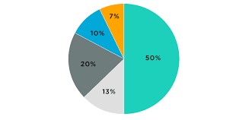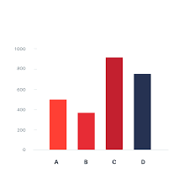

**Tools & Packages**

|  |  |
| --- | --- |
| **Tool/Package** | **Purpose** |
| Python | Data analysis |
| SPSS | Data visualization |
| Google Forms | Data collection |

We used various tools and packages to analyze and visualize our data. These include R for data analysis, SPSS for data visualization, and Google Forms for data collection.

**Conclusion**

Marginal workers in TN face several challenges that prevent them from improving their financial and social status. Our analysis approach, which involved primary data collection and secondary data analysis, helped us better understand their situation and identify potential solutions. We hope this document provides valuable insights to stakeholders interested in improving the conditions of marginal workers in TN.